**Code compilation in Linux box**

**Configurations:**

**I.Putty:**

**Need access to the below server to access and build the code in Linux box.**

**VLLTCNPCIDEV1.fisdev.local**

Once you got the access , please configure this server in putty and save it.

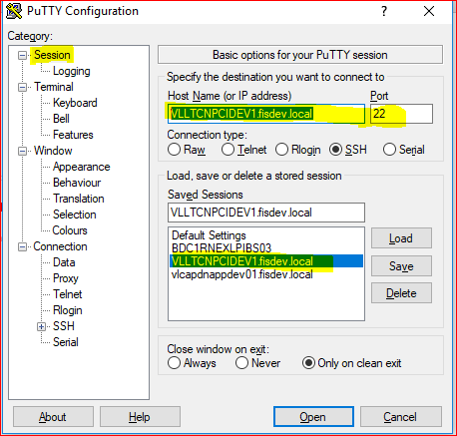

**2.WINSCP**

**Configure the same in WINSCP to move/view the code changes and save the session using your domain EID and password.**

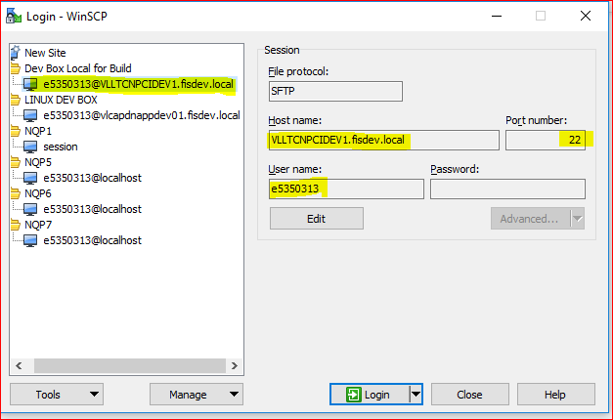

**Code Build/Changes:**

Once configurations are done, please login to the server using domain Eid and password in putty.

Step1: Go to the code/build location (/dnserver/devel) and you can see list of software and data center MU folders.

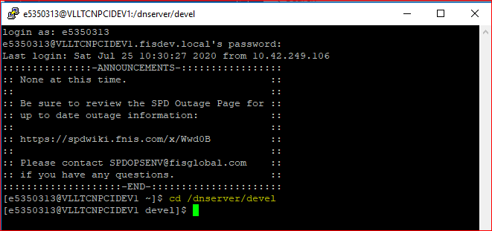

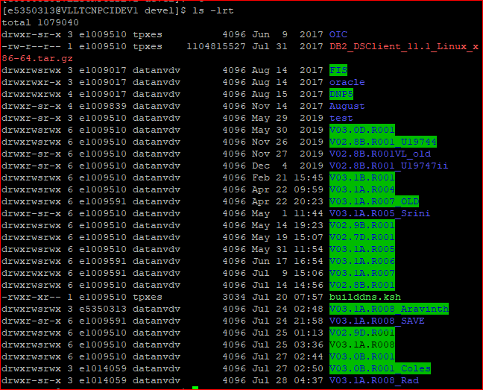

**Step2:Create a new build folder**

If you want to make/include any changes on top of the current build for your testing purpose, then make a copy of the original MU folder to your new build folder.

For Example, I have copied the August MU level code to new folder called V03.1A.R008_Aravinth.

**Copy command:**

**Create a mu folder(V03.1A.R008) within your build folder (V03.1A.R008_Aravinth) and copy the files from original MU folder to your folder.**

**cp -r --preserve V03.1A.R008 V03.1A.R008_Aravinth\V03.1A.R008\**

Here, Preserve will present the previous build details and it will allow to build only the new change modules instead of making complete build.

V03.1A.R008 – Source folder

V03.1A.R008_Aravinth – Destination folder.

Also, copy the builddns.ksh file from **/dnserver/devel** to your folder **V03.1A.R008_Aravinth\V03.1A.R008**)

Note: The original build folder should present within your new build folder like below.

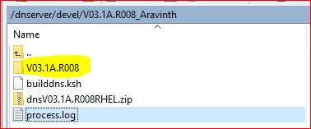

**Step3: Move changes to Linux Box.**

Once the build environment / folder got created move your changes through WINSCP from your local to Linux box.

Eg.

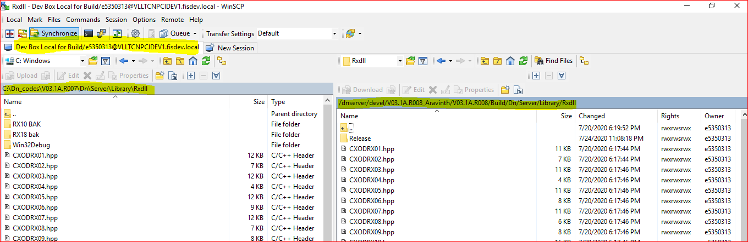

**Step4: Build changes**

After moved the changes to Linux box, Start build the code by using the below command.

Command: **builddns.ksh V03.1A.R008 Noget Build Release**

Once build completed , please see the **processlog.txt** file to see error details which you got during the build.

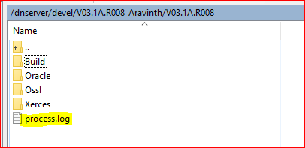

Once the build is completed new archive file would be created in the bin folder**.**

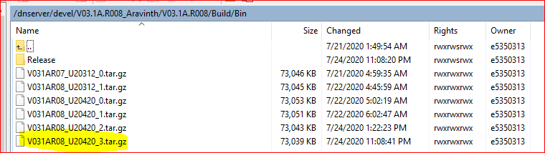

**Step5 : Copy the tar file to Linux Dev box.**

Copy the tar file to Linux Dev BOX or the testing location where you want and extract the changes in bin folder.

**Dev box:**

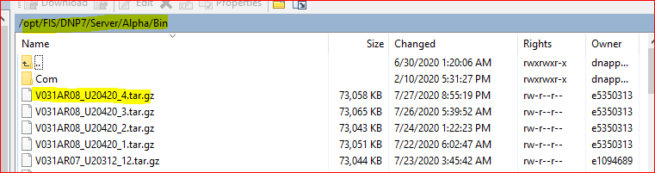

Extract the changes in bin folder using the below command .

**Command:**

tar -zxvf V031AR08_U20420_4.tar.gz

Once the changes are extracted bounce the server/switch.

Stop command:

stopDN.ksh FM / stopDN FM

Start Command:

startDN.ksh FM or startDN FM